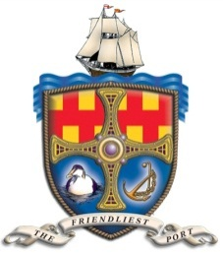
Warkworth Harbour Commissioners

Harbour Dues & Charges 2019

- Fishing Boats

- Permanent fishing boats £10.50 per metre
- Permanent fishing boats low landings £24.00 per metre
- Casual fishing boats landing £6.25 per night
- Casual fishing boats not landing £24.50 per night

- Miscellaneous Charges

- Fish Landing Dues 4% per £ advalorem
- Ice £80.00 Per ton
- Over the side/through put oil deliveries £1.5p Per litre
- Water not using quayside meters £10.00
- Refuse/skip usage £10.00

- Angling/Charter Boats

- Home port boat on Quay berth £38.50 per metre
- Home port boat on mooring £31.75 per metre
- Home port boat – Permit £255.00 per annum
- Casual visitors £47.00 per night

- Pleasure Boats

- Boat on permanent mooring £32.50 per metre
- Boat using port on casual basis up to 10m £18.75 per night (£22.50)
Over 10m £22.08 per night (£26.50)
c. Casual launch Harbour Dues £15.21 per day (£18.25)
£39.13 per week (£46.95)
£78.75 per annum (£94.50)

All Charges exclusive of VAT @ 20%

